SIMPLE OVERVIEW

Create your audio collection in html in 2 steps !

A simple nice blue exports from milka (amilino@gmail.com). Very fast to use.

Installation:
Click on 'Start' in the taskbar and run the Execute/Run-command. Type the following in the box:
%appdata%/Mp3tag/export
An explorer window will open and there you can copy the export scripts to.

Recommended:
Place picture cover.jpg in each album folder. Or you can open the export script or the output file and
look in the script area the following line:
// ++++++++++++++++++ DEFINE THE NAME +++++++++++++++++++ //
Below this line there is a brief description and you can define the name of the covers you wont to use.
So when you don’t wont to call your covers in the directories "cover.jpg", simply edit the line.

Tags:
%title%, %artist%, %album%, %genre%, %comment%, %encodedby% (I use it for showing what’s
included in ID3 tag)

These fields are user-defined fields for ID3v2.x and ID3v1. So they are all sub-tags of the "User
defined text information frame" (TXXX). All user-defined tags are stored there. Like every other
user-defined field they are created for special reasons. They help to catalog the music much better.

Writing tags:

User-defined fields are easy to access. In Mp3tag you click on a song, press the keys [ALT]+[T] and
then on "Adding new tag-field" On the list, where you can choose a field, you can type for example
ARTIST and then you can type artist name in the value in the field below.

Usage (example directory: C:\Music):

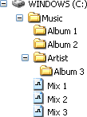

- Step (Album Overview):
- Change directory … [Ctrl]+[D] --> Music
- Export [Ctrl]+[E] --> milkaSimple 01 html Album Overview.mte (activate 'One file per directory')
- Export [Ctrl]+[E] --> milkaSimple 02 m3u Album Playlist.mte (leave 'One file per directory activated')

- Step (Album & Mix List):
- Export [Ctrl]+[E] --> milkaSimple 03 html Album & Mix List.mte (uncheck ‘One file per directory’)
- Export [Ctrl]+[E] --> milkaSimple 04 m3u Album & Mix Playlist.mte (leave 'One file per directory'
unchecked)

Manual:
Open source code of each html placed in album folder and replace:
COPY, PASTE REVIEW HERE ! with album review.

Run c:\Music\Music.html

Support:
IE **********
Opera **********
Mozilla Firefox **********

Screenshots:

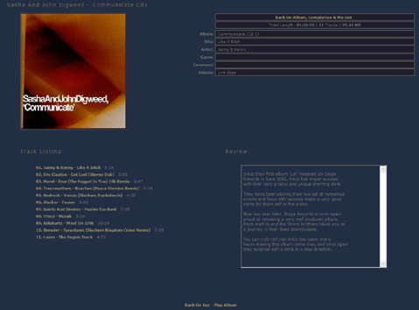
Album Overview

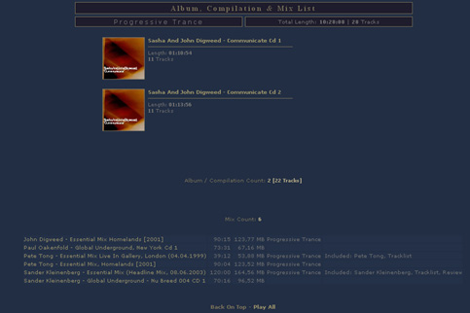
Album & Mix List

History Of Changes:

----------------------------------------------------------------------------
NEW: support for multiple albums in one directory.
----------------------------------------------------------------------------
NEW: name of the cover now can be defined.
CHG: now the cover-popup supports Opera without switching it to Mozilla or
Internet Explorer in the settings.
FIX: improved back on list link.
----------------------------------------------------------------------------
FIX: wrong bitrate.
----------------------------------------------------------------------------
CHG: removed zero if it is first digit in length.
FIX: it is now possible to use ' (apostrophe) in folderpath or filename and
# (number sign) at beginning of folder or filename.
----------------------------------------------------------------------------
FIX: removed blank lines in album & mix list.
----------------------------------------------------------------------------
CHG: review is in textbox and in same level (row) as tracklist.
----------------------------------------------------------------------------
FIX: playlists are ANSI encoded.
----------------------------------------------------------------------------
NEW: auto-sizing image popup window.
NEW: link "Back On Album, Compilation & Mix List " now support long path
(thanks to feature request folderdepth).
NEW: bitrate in info table.
----------------------------------------------------------------------------
CHG: some font colors are changed.
FIX: Tracks was wrong written (Tacks).
----------------------------------------------------------------------------
NEW: added comment in album list.
NEW: mix counter.
NEW: total album tracks counter.
CHG: font size is smaller.
CHG: new look of mix list table.
CHG: length format is minutes:seconds for mixes.
FIX: length was wrong written (length) in album & mix list.
FIX: zero hours in length are not shown anymore (ex: before 00:53:21,
after 53:21).
FIX: album counter was wrong when mixes were not on list.
----------------------------------------------------------------------------
CHG: bigger title font size.
FIX: big distance between title and mix list when albums are not on list.
----------------------------------------------------------------------------

